CoolProp in Labview
Sergei Gusev, Ghent University sergei.gusev@ugent.be

How to Install
Download the files CoolProp.llb and CoolProp.dll to a folder on your hard drive. The default path is C:\Labview\Libfolder\. You can either create such a path or save the files somewhere else, in this case you have to modify the path in the initialisation file (will be explained further).
The CoolProp.llb file is a library containing initialise_coolprop.vi and calculate_coolprop.vi making CoolProp working in Labview. You can see the content of the library by double-clicking on it:
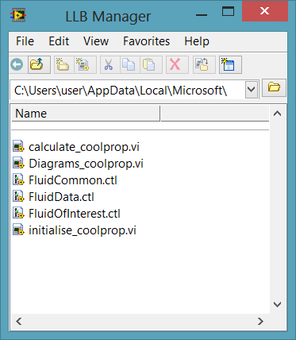

Getting started
Open a blank project
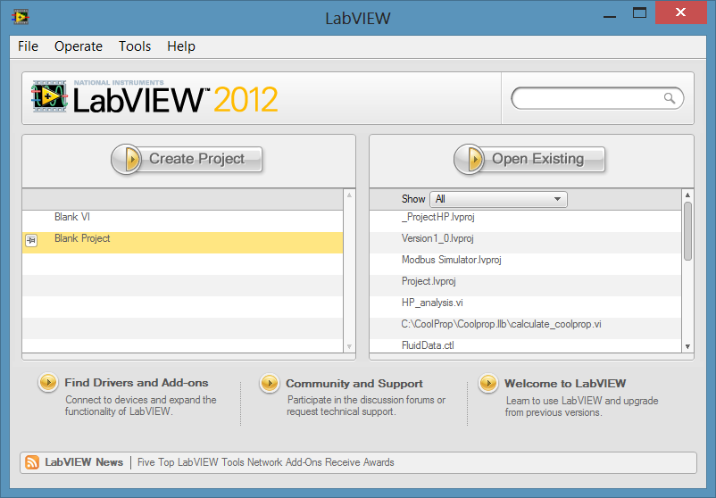
Drag and drop the CoolProp.llb library into the project as it shown:
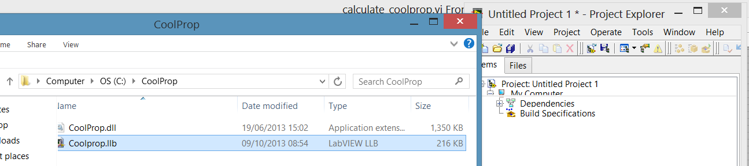
Expand the library, you should see the following:
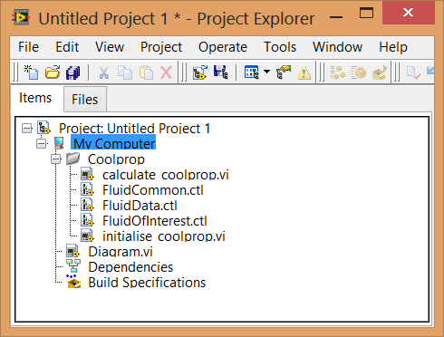
Open the Block Diagram of your Diagram.vi, drag and drop initialise_coolprop.vi and calculate_coolprop.vi into it. Use the Context Help to explore these VI’s:
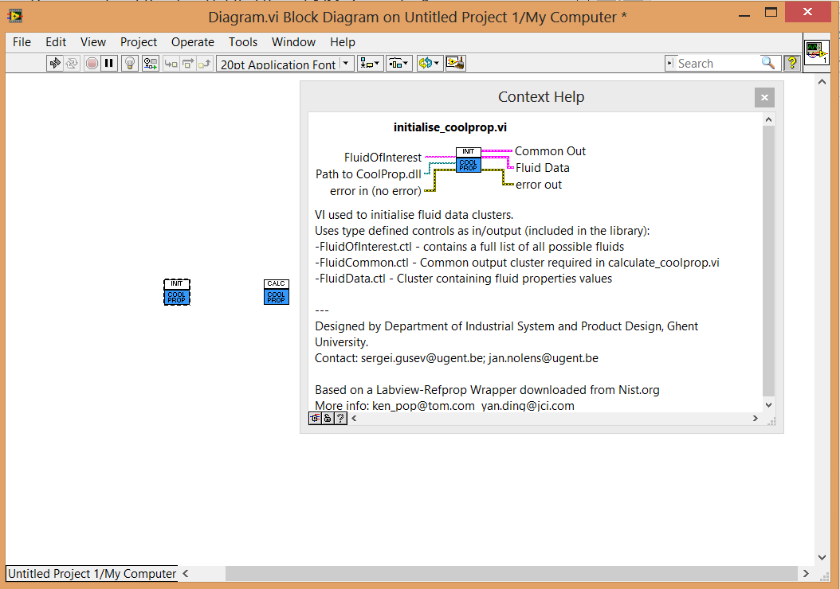
Make two controls to initialise the CoolProp:
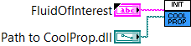

You will see it also on the Front Panel:
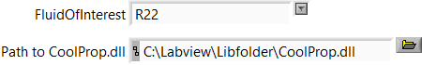
You should change the default path if you saved the CoolProp somewhere else.


Tip: After you’ve adjusted the path, right click on it and go to Data Operations Make Current Value Default.

Connect the calculate_coolprop.vi as follows and create input controls and output indicators:
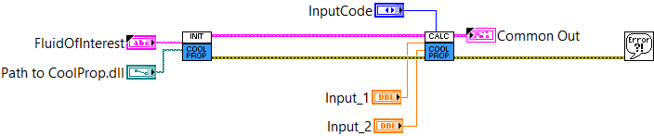
Input Code:
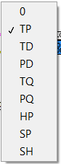
You can choose one of these combinations to define the input parameters: pressure, temperature, vapour quality etc.
Modify the values of FluidOfInterest, Path to CoolProp.dll (if necessary), Input_1 and Input_2. If everything configured right, you will be able to calculate properties of the fluid chosen (output cluster on the right):

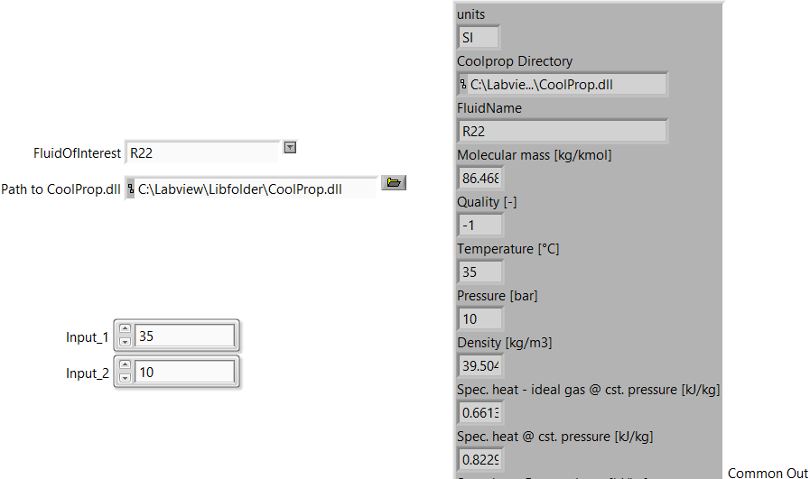

How Diagrams.vi works

To define the boundaries of diagrams, Crit. Temperature and Minimum Temperature calculated in initialise_coolprop.vi are used.
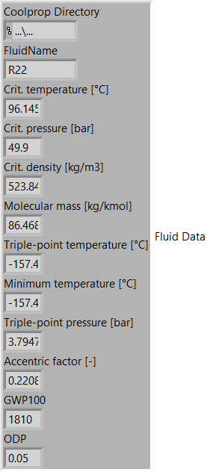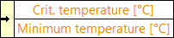
The saturation curve is a composition of two curves plotted for saturated liquid and saturated vapour (input parameter Q is equal to zero and one respectively).
To connect these curves Build Array function is used: 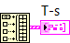
To embed a cycle data into your diagrams, you need to calculate the entropy and enthalpy for each point first (calculate_coolprop.vi) assuming pressures and temperatures are measured.
You can connect sequentially as many calculate_coolprop.vi as you need one for each point. If the input_1 and input_2 are not defined, values are taken from common out of the previous calculate_coolprop.vi.
Example: expansion through a throttle valve and evaporation until the saturation point.
Make arrays of these values, start and finish with the same point so your cycle closes. Add these arrays to your diagrams using bundle function.
Expected result:
